RESOURCE-SAVING INNOVATION: MAMMUT LOOPINSULATION
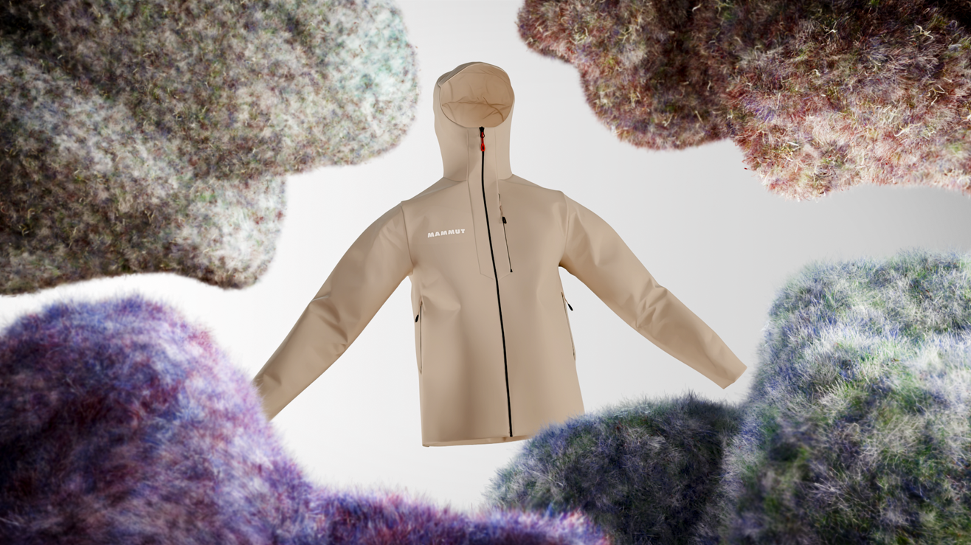Insulation material from industrial rope production scraps (Photo: ©Mammut Sports Group AG)

Swiss mountain sports outfitter Mammut is raising the bar in resource conservation and performance for the 24/25 winter season with the launch of its Mammut Loopinsulation. This groundbreaking insulation solution marks another significant step towards a more environmentally friendly future.

Mammut Loopinsulation is the result of a successful collaboration with Austrian rope manufacturer Teufelberger. This innovative insulation material is made from production scraps generated during industrial rope manufacturing. Through a mechanical recycling process, free of chemicals, these scraps are transformed into high-quality insulation. "With Mammut Loopinsulation, we are embracing a circular and resource-conscious approach to material reuse. This is a critical step toward the future of sustainable outdoor clothing," explains Helena Theba, Material Management Lead at Mammut.
From concept to innovation
The development of Loopinsulation began after an analysis of Mammut's carbon footprint in 2018, which revealed that 13% of the company's CO₂ emissions came from rope manufacturing. In response, Mammut conducted extensive research on repurposing rope production scraps, leading to the creation of Loopinsulation, a technology that stands out for its efficiency and environmental benefits.
First milestones and challenges
For the 2024 fall and winter season, Mammut has successfully recycled 12 tons of rope scraps, converting them into valuable insulation material. A key challenge was the variation in rope diameter, quality, and color, which was overcome through innovative solutions and a robust logistics system. "The complexity of recycling processes should never be underestimated," says Theba. "A circular economy demands significant effort and expertise."
A practical example: The Sender IN Hooded Jacket
One example of Loopinsulation in action is the Sender IN Hooded Jacket. This insulation jacket combines Loopinsulation with a recycled, wind- and water-repellent outer shell, moving Mammut closer to a fully circular, eco-friendly production process.

Website:
https://www.mammut.com/int/en/mammut-loopinsulation

YouTube video:
https://youtu.be/H6wN7HsIDVM

About Mammut
Mammut is a Swiss outdoor company founded in 1862 that offers mountain sports enthusiasts worldwide high-quality products and unique brand experiences. For 160 years, the world's leading mountain sports brand has stood for safety and pioneering innovation. Mammut products combine functionality and performance with contemporary design. With its combination of hard goods, footwear, and clothing, Mammut is one of the complete suppliers in the outdoor market. Mammut Sports Group AG is active in around 40 countries and employs approx. 850 people.
mammut.com

